**Technical Documentation – PENC MiddleWare – Deploy_Digital_Services_Config_Files**

1. Workflow – Deploys Digital Services Configuration files to Digital Services Servers. The workflow can be modified to



1. Survey – User Supplied Variables

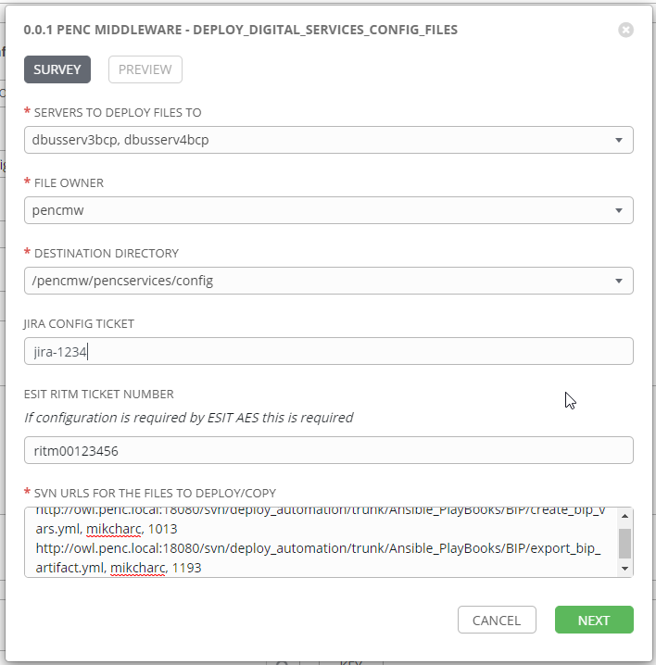

| **Survey Extra Variables** | **Prompt** | **Type** | **Description and Usage** |
| --- | --- | --- | --- |
| destination_hosts | Servers To Deploy Files To | Multiple Choice Single Pick | This is a drop down list of current digital services hosts. It can be modified for any number of hosts if required. Current Drop Down List:  dbusserv3bcp  dbusserv4bcp  dbusserv3bcp, dbusserv4bcp  tbusserv3bcp  tbusserv4bcp  tbusserv3bcp, tbusserv4bcp  mbusserv3bcp  mbusserv4bcp  mbusserv3bcp, mbusserv4bcp  pbusserv3bcp  pbusserv4bcp  pbusserv3bcp, pbusserv4bcp |
| file_owner | File Owner | Multiple Choice Single Pick | Linux user that will own the files deployed. This can be modified to add directories if required. Current Drop Down List:  pencmw  oracle |
| Destination_Directory | Destination Directory | Multiple Choice Single Pick | Linux directory to copy the files to. This can be modified to add directories if required, Current Drop Down List:  /pencmw/pencservices/config  /pencmw/pencservices/bin |
| JiraNumber | JIRA Config Ticket | Text | Optional freeform text area – If it is populated the send_notice_to_aes job includes the JiraNumber in the email notification. |
| RitmNumber | ESIT RITM Ticket Number | Text | Optional freeform text area – If it is populated the send_notice_to_aes job includes the RitmNumber in the email notification. As well the deploy files job copies the FileArtifacts to the Destination_Directory with an Extension of RitmNumber. This allows any changes the RITM Ticket includes to be applied by AES prior to putting the file in place. |
| FileArtifacts | SVN URLS For the Files To Deploy/Copy | Text Area (20K) | Required Text Area with the SVN URLS (one line per artifact) of the format:  http://owl.penc.local:18080/svn/repo/artifact_name, username, revision_number.  SVN Urls are typically around 150 characters, so over 100 artifacts could potentially be deployed at once.  i.e:  http://owl.penc.local:18080/svn/deploy_automation/trunk/Ansible_PlayBooks/BIP/deploy_bip_artifacts_new.yml, mikcharc, 1047 |

1. Jobs Used by the workflow - http://owl.penc.local:18080/svn/deploy_automation/trunk/Ansible_PlayBooks/Utilities

| **Job Template** | **Ansible Playbook** | **Credentials / host** | **Project** | **Description and Usage** |
| --- | --- | --- | --- | --- |
| create_file_copy_vars | create_file_copy_vars.yml | None – runs on localhost as awx linux user | Utilities | Creates Variables/Artifacts for use within the workflows, based on the User supplied survey results.  Artifacts Defined with examples  StageDir: /codemove_common/dp_automation/stage/file_copy  date_time: '20201204_092625'  stage_server: diagoras1bcp  tower_hostname: pdeploy1bcp.penc.local |
| stage_file_artifacts | stage_file_artifacts.yml | Codemove for {{stage_server}} – diagoras1bcp  pendeploy_svn – used to extract artifacts using the svn urls supplied. | Utilities | Stages File Artifacts from a SubVersion repository to the {{StageDir}}/{{date_time}} directory on the {{desination_hosts}}. |
| deploy_files | deploy_files.yml | {{file_owner}} on {{destination_hosts}} | Utilities | Copies files from {{StageDir}}/{{date_time}} directory to the {{Destination_Directory}} using the Ansible ‘copy’ module. If the file already exists it creates a backup of the file. If {{RitmNumber}} is defined it will copy the file artifact with an extension of {{RitmNumber}}. This allows AES to modify the file based on the associated ritm ticket |
| send_notice_to_aes | send_notice_to_aes.yml | None – runs on localhost as awx linux user | Utilities | Sends a notice to mail addresses in {{mail_list}} that the {{FileArtifacts}} were copied to directory {{Destination_Directory}} on {{destination_hosts}} |

1. Workflow Extra Vars – Defined at the Workflow Level

|  |  |  |
| --- | --- | --- |
| **Extra Variable** | **Example Values** | **Description and Usage** |
| mail_list | ---  mail_list:  - Mike.Charchuk@pensionsbc.ca  - jamie.gibbon@pensionsbc.ca | This is variable is used within the send_notice_to_aes job/playbook as the ‘to:’ list for the Ansible mail module that notifies staff that the files have been copied/deployed to the host(s). |